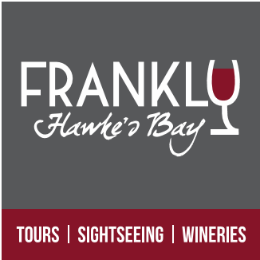

Cruise Boat Hawke’s Bay Excursion
HAWKE’S BAY PRIVATE HIRE TOUR
5+ hours

Tour timetabled to meet ship arrival and departure.
$950.00 (10 seater Mini Bus)

A varied and insightful tour showcasing the heritage, rural vistas and produce of the Hawke’s Bay region in and around the cities of Napier, Hastings and the village of Havelock North. Small tour group personalised (max 10) hosted by a local guide.
- A Guided understanding of Napier’s Art Deco Heritage and History.
- Enjoy the Views from Bluff Hill (photo opportunity)
- Visit the historic Mission Estate Winery (NZs Oldest)
- Enjoy the rural scenery and commentary as we head out to the Gimblett Gravel Wine Region
- Visit and sample wine at 2 Boutique wineries.
- Winery lunch (own cost)
- Visit and sample NZ Honey at Arataki Honey House.
- Marvel at the breath-taking 360deg views from Te Mata Peak.
- Visit and sample freshly picked Berries, Apples, peaches... at the source (seasonal availability) with a fresh fruit ice cream.

Please note: This is a sample itinerary, being private hire you are welcome to customize a tour to your interest and timing, perfect for groups, families or find likeminded guests on your ship to share the cost.
Some venue fees included, Lunch own cost/discretion
Deposit not required – Payment due when we meet ashore on the day.
To book or make enquires please email : info@franklytours.nz

