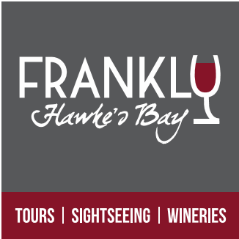

Cruise Boat Hawke’s Bay Excursion
HAWKE’S BAY FRANKLY
3 Hour Morning Tour
9:00am – 12:00pm
$70pp

A varied and insightful tour showcasing the heritage, rural vistas and produce of the Hawke’s Bay region in and around the city of Napier.
Small tour groups and personalised (max 10)

- A Guided understanding of Napier’s Art Deco Heritage and History.
- Enjoy the views from Bluff Hill (photo opportunity)
- Visit a sheepskin factory store
- Enjoy the outlook, gardens and historic stories at Mission Estate
- Enjoy the coastal scenery as we head north and inland to the beautiful Esk Valley
- Visit and sample freshly picked Berries, Apples, peaches... at the source (seasonal availability) with fresh ice cream
- Visit and sample boutique wine at Linden Estate

Please note: This itinerary could change or substitute in order to avoid weather conditions.
This itinerary has been specifically formulated to avoid the crowds and return you in good time to explore the Napier inner city at your own leisure before your ship departure.
Deposit not required – Payment due when we meet ashore on the day.
To book your seats please email : info@franklytours.nz

